Project Leader: Roshan Dhital (30361962)

Product Owner: Kamal Pun (30371365)

Scrum Master: Riaz Qadir (30364968)

Programmer: Jashandeep Singh(30362218)

Developer: Haque Mohammad (30379834)

Project Handbook

Babatye mobile app for barcode reader

Table of Contents

Preface 3

Vision Statement 3

1. Introduction 4

1.1 Project Overview 4

1.2 Project Deliverables 4

1.3 Evolution of the Handbook 5

1.4 Reference Materials 5

1.5 Definitions and Acronyms 5

2. Organization 6

2.1 Process Model 6

2.2 Organizational Structure 7

2.3 Organization Boundaries and Interfaces 8

2.4 Project Responsibilities 10

3. Managerial Process 10

3.1 Managing Application’s Aspects 10

3.2 Resource Acquisition Plan 11

4. Technical Process 11

4.1 Methods, Tools, and Techniques 11

4.2 Software Documentation 14

4.3 Plan for crating user and technical documentation 15

5. High level Project Plan 16

6. Non-functional Requirements 20

6.1 Platform 20

6.2 Communication 20

6.3 Performance 20

6.4 Security and Privacy 20

6.5 Audience 20

6.6 Reliability 20

6.7 Modifiability 21

6.9 Usability 21

6.10 Standards 21

7. Software and Systems Architecture 21

7.1 Architecture objectives 21

7.2 High-level architecture 21

7.3 System context 22

7.4 User Interface / Interaction Design 23

7.5 Data model and software design 24

7.6 Assumptions 25

7.7 External Dependencies 26

Preface

*This report illustrates how we as a team will be dividing the work and completing our Project. This report will also include details regarding our vision and plans for the project and is intended to insight respective viewers of the report about the features and outcome of the Product.*

# Vision Statement

*Overview*

*Babatye is a Melbourne, Australia based online clothing brand launched in 2018. It is a local business with global presence bringing fashions to you at the click of a button. Babatye works with external suppliers for their cloths. As required by client we will be working to build a mobile app for barcode scanner for Babatye online clothing store.*

1. Problem Description

*Babatye has been manually storing information of their cloths form suppliers into their data repository which is very time consuming and unproductive.*

1. Envisioned Solution

*Transfer into a more flexible system based on mobile that will let them to scan the barcodes of cloths received from suppliers at the time of delivery. And the scanned data should be stored into their data repository where the information should be correct and unique.*

1. System Capabilities
2. *Create login for company’s personnel only so that others can’t access to it.*
3. *Simple usable scanner app.*
4. *Scan all types of barcodes.*
5. *Manually enter product item details.*
6. *Scanned item’s data stored into data repository.*
7. Business Benefits

*With the use of the product business can reduce time to update information regarding item from suppliers. Any damaged or missing items can be managed easily from database information. Manage stock availability. Review item information.*

# Introduction

## 1.1 Project Overview

* *Problem Statement: This part addresses the major issues which are to be solved by the project. Those major issues to be considered are:*

1. *Lack of barcode scanner created problem to know the details of a product and was inconvenient in buying and selling process.*
2. *Investors, management team, workers, suppliers of the company and the customers are having problem.*
3. *Influence of the problem to an organization. Investors and workers of the company in manufacturing products could not have digitalized process to calculate the type and quantity of products sold and could not manufacture products accordingly.*
4. *Description of plausible solutions to the problem created and key benefits of it. Barcode reader application solves the problem by storing information about product price, quantity sold, which category under the same product item was sold, and restocking information so that workers perform on the inventory part, and updates changes.*

* *Project Position: Barcode reader is crucial in terms of determining product items and gathering its information accordingly. The scanning tool of a barcode gets more better if it’s portable so that it can be handy wherever we travel and when considering of an barcode reader application design that each of the participants in buying and selling purpose can have an access. Based on developed application, special considerations on the functionalities within will be monitored and will make changes from suppliers, customers, and management team side to reduce hassles which may arise.*
* *Organisational Position: This project will be on behalf and assist in the management of inventory making it effective to the workers and adding value to the entire product development team through the means of barcode reader application. Also, it assists the management team to take necessary actions regarding the restock of desired products, tracking each of the products, and taking feedbacks from the customers and working accordingly.*

## 1.2 Project Deliverables

*Towards the end of the project we will be handing a complete application to our client that will be able to scan any barcodes through mobile app and store those data into cloud-based data repository. With which they can keep record of their supplies from each supplier. Client will also be provided with a user manual describing every step required to use the application.*

## 1.3 Evolution of the Handbook

*When preparing our complete project handbook, we considered following things:*

* *When will scheduled updates happen?*

*Before any assessment submission*

* *Who is responsible for updates?*

*Everyone in group*

* *How will you put the handbook in change control?*

*Through GitHub*

* *How will everybody be notified of handbook changes?*

*Through stand-up meetings*

## 1.4 Reference Materials

*Since this report is original and all the works and report has been done by our own brainstorming, use of external resources is at minimum and only reference is used through course content.*

*Template for Handbook: Moodle*

## 1.5 Definitions and Acronyms

*Following are the references to the definition of, terms, acronyms, or abbreviations used in the handbook.*

|  |  |
| --- | --- |
| Term | Definition |
| *Data Repository* | *Place where data is hold, made available and organized in a logical manner.* |
| *Barcode* | *Number that is like a fingerprint for products.* |
| *Information* | *Stored data in data repository.* |

# Organization

## 2.1 Process Model

*The first stage for this project has already begun, we as a team divided out tasks among ourselves and have chosen the project manager and scrum master. Project manager will be taking care of the project so that everything is going well, if there is any hurdle then the Project manager will take care of it. While on the other hand, Scrum master will be taking care of meetings held every week with the client and supervisor. Everyone is accompanied with their desired tasks and has already begun to start working after the meeting with our client.*

*This is the rough breakdown of activities which we will be doing to succeed in this project.*

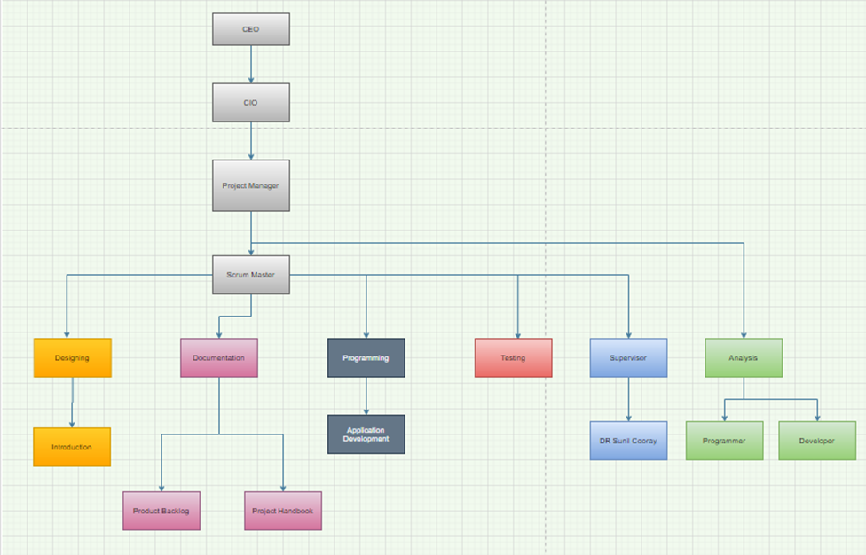

*We will be having meetings every week with our client as well as supervisor and will be keeping them updated on the work time to time. The platform chosen for meeting with our client is zoom, as suggested by the client with her feasibility. We have chosen a particular day and time to have a virtual meeting with the client and supervisor and have created a group on WhatsApp in case of any changes in the plan.*

*This is breakdown of work that will be done thorough the Project 1.*

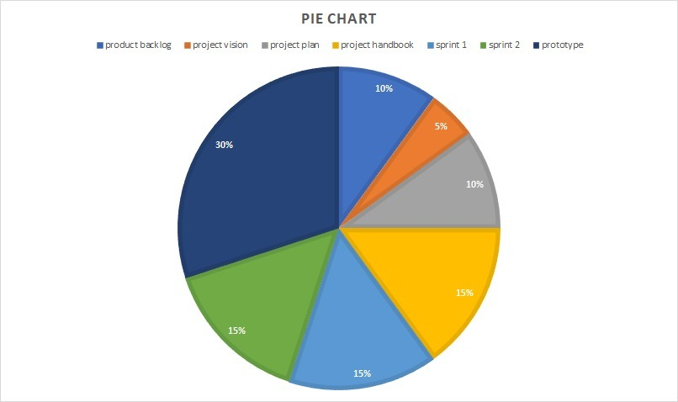

## 2.2 Organizational Structure

*The structure for this is that we will be doing this project in two parts. The initial part which is Sprint 1: this will be the documentation part where we will be analysing and designing the system whereas the second part will be Sprint 2: where we will be developing a Design for the app.*

*There are three basic roles for scrum:*

*1. Product Owner*

*2. Scrum Master*

*3. Team Member*

*We have divided the roles among us and will vary each week as everyone will be having an opportunity to show their managerial and leadership skills. This week’s Product Owner and Scrum Master are:*

|  |  |
| --- | --- |
| *Product Owner* | *Kamal Pun* |
| *Scrum Master* | *Riaz Qadir* |

## 2.3 Organization Boundaries and Interfaces

*As the project is divided into two parts Sprint 1: (documentation part) and sprint 2: (Design part). In the start things really were not in our favour, Our team was the only team who did not have a meeting with the client for a bit long due to some issues, while the other teams already had their few meetings. But finally, we sorted out our issues and had a meeting with a client on zoom video call. This was the first meeting where we had no experience of how to present ourselves in the professional industry, but things really went well as the client went happily from us and fixed the date for the next meeting too.*

*The roles which we have decided till now are the roles of Scrum Master and Product Owner. These two roles will be rotating among team members every week.*

*Below is the RACI model which tells about the tasks of each stakeholder for this project.*

|  |  |
| --- | --- |
| *R* | *RESPONSIBLE* |
| *A* | *ACCOUNTABLE* |
| *C* | *CONSULTED* |
| *I* | *INFORMED* |

|  |  |  |  |  |  |  |  |
| --- | --- | --- | --- | --- | --- | --- | --- |
| *Tasks* | *Client* | *Supervisor* | *Project Leader* | *Product Owner* | *Scrum master* | *Programmer* | *Designer* |
| *Assign project Leader* |  | *R* |  | *C* | *C* | *C* | *C* |
| *Assign Project Owner* |  | *R* | *R* |  | *C* | *C* | *C* |
| *Assign Scrum Master* |  | *R* | *R* | *C* |  | *C* | *C* |
| *Identify Stakeholders* | *C* | *C* | *R* |  |  |  |  |
| *Identify Main Tasks* | *I* | *C* | *R* | *A* | *C* | *C* | *C* |
| *Work Breakdown Structure* | *I* | *I* | *R* | *A* | *C* | *C* | *C* |
| *Keeping Track with Deadlines* | *I* | *C* | *R* | *A* | *C* | *C* | *C* |
| *Communication Management* |  |  | *A* | *C* | *R* | *C* | *C* |
| *Risk Management* |  | *I* | *C* | *R* | *C* | *A* | *C* |
| *Quality of work* | *C* | *C* | *R* | *C* | *C* | *A* | *A* |
| *Keeping track of team members* | *I* | *C* | *R* | *A* | *C* | *C* | *C* |

*The mode of communication chosen by our client and us is, zoom video call where our client will be creating a room and we will be getting the link via email or through WhatsApp as preferred by the client. Scrum master will be responsible for the communications as it is the role of the Scrum Master to take care of communications with client and supervisor.*

## 2.4 Project Responsibilities

*The responsibilities are divided among each of us by their own choice as per their interests towards this project.*

|  |  |  |
| --- | --- | --- |
| *Stake holders* | *Represent* | *Roles* |
| *Roshan*  *Dhital* | *Project*  *Leader* | *Roshan is the project Leader of our team where he will be looking after the team and work and where needed, he will be guiding us as project leader has got major responsibility of the team.* |
| *Kamal*  *pun* | *Product*  *Owner* | *Product owner is the one who will be prioritising the necessary work and has a responsibility for managing the requirements. It is the duty of product owner to finalise the work.* |
| *Scrum*  *Master* | *Riaz*  *Qadir* | *Riaz will be looking after the communications with client and supervisor as a scrum master it is his role to keep track of every change is documented and process is followed properly* |
| *Jasshandeep*  *Singh* | *Programmer* | *Jass is the team member who will be looking after the coding and programming of the app.* |
| *Muhammad*  *Haque* | *Designer* | *Muhammad will be assisting Kamal in overall reports and will be designing the basics of the app.* |

# Managerial Process

## 3.1 Managing Application’s Aspects

*The focus of our team is to give such platform that can lead the application’s required features with respect to business aspects and to meet our client’s requirements as well with ERP diagrams , we will be managing our application throughout their lifecycle.*

* *Prototyping*

*As prototyping can be helpful in managing and understanding the business process or IOS and Android apps platforms, we will consult with a professional UX/UI designer.*

* *UX/UI Design*

*Our vision for user interface and user experience design is that it should be designed and managed in such a way that will maximum comfort and benefit to the user.*

* *Testing*

*As Quality Assurance is a key part of the development cycle. via QA we will make sure our app will work as it should and will not crash upon performing its task.*

## 3.2 Resource Acquisition Plan

* *Development Resources*

*We will be using roughly 3 software and hardware tools that will be required by us for executing our application the project*

*Software- Ms project etc*

*Hardware- windows 10 etc*

* *Test Resources*

*For quality assurance testing resources of our barcode scanning system, which we will be using are-*

*For programming*

*Google dev tools https://developers.google.com/web/tools/chrome-devtools/open*

*For java code testing*

*Jsfiddle https://jsfiddle.net/sibeeshvenu/upnxe8jp/4/*

# Technical Process

## 4.1 Methods, Tools, and Techniques

*To work with rest of the member of our team we use several app to communicate. When we need to massage someone to about something, we did use this application which is handy can be use in anywhere any time. So, for documentation we did use the google doc online. It is very easy to use and can be use both from mobile phone or laptop not need very high graphic or technology to use it and whenever we need to add something everyone can see the work and change whenever they need.*

*We are a team of five member need to divide all the task in very responsible way so they can work based on that and can be reached in the goal without delaying the process. Here is our scrum framework we will be working based on that throughout the semester.*

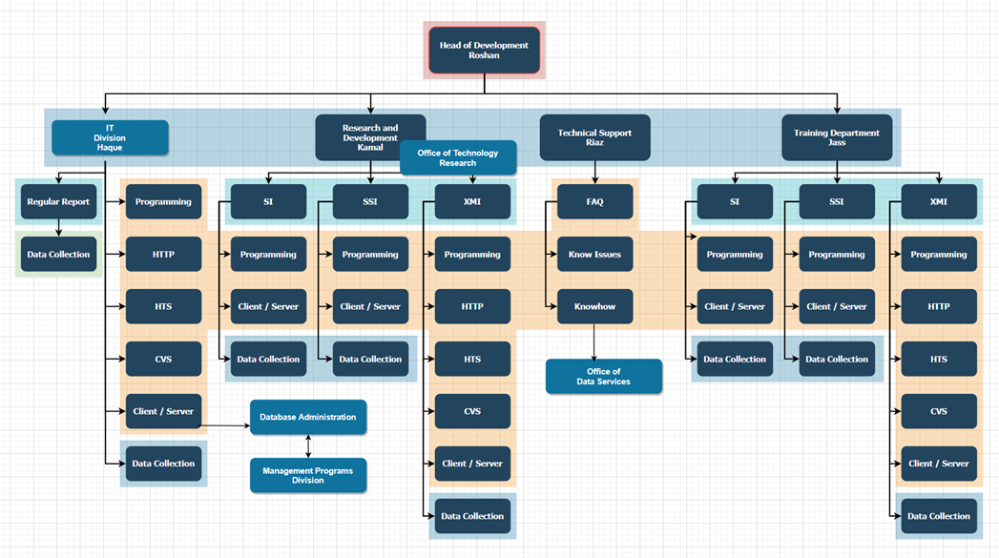

*Fig: Role and position of each member in the team*

*For software design we use draw.io which is online based and completely free we can draw the diagram and chart very easily over there. ERD diagram, UML diagram, crow foot notation and many more diagram we will design throughout developing our project.*

*For document and code management we will be using GitHub and Microsoft excel and access which we have default in our laptop but for GitHub we just need to create an account to use.*

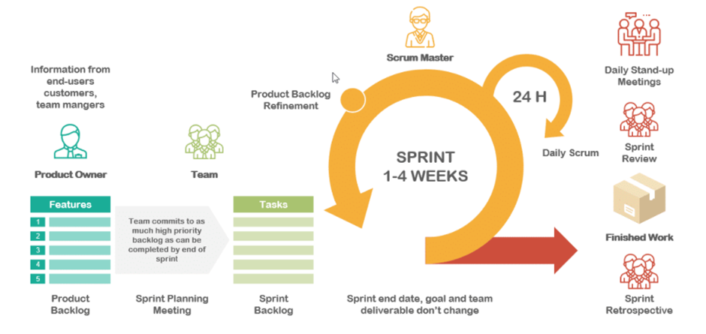

*Fig: Scrum Framework*

*For the last 7 week we all are working on the project plan, guild line what to do what not but from now on we will be start working on the main prototype work. we will be discussing more in the presentation demonstration.*

***Communication tools:*** *Throughout the course for this semester In order to finish our project we need to contact with multiple people and in the time of pandemic when its lockdown going on here, we have no option but to contact through online and here is how we maintain that with all these people.*

|  |  |  |  |
| --- | --- | --- | --- |
| *Contact with the group member* | *Contact with the client* | *Contact with tutor* | *Contact with supervisor* |
| *What’s app* |  |  | *What’s app* |
| *Mobile phone* |  | *Email* | *Adobe connect* |
|  | *Zoom* | *Adobe connect* |  |
|  | *Email* |  |  |

***Tools and software use for documentation coding and tracking our work:*** *For this semester to design and documenting our work for this project we must use lots of application, tools, and software some were free some we have to use our university identity, and some was trial version. Here is all of them until now we use for our project and rest of the year, we hope we will be working on those.*

|  |  |
| --- | --- |
| ***Software or tools*** | ***Uses for*** |
| *Microsoft team, GitHub* | *Tracking the work and see the progress overall.* |
| *MIT inventor* | *Interface and design the prototype.* |
| *Draw.io, Lucid chart* | *Illustrate the diagram and flowchart.* |
| *Python, java* | *Coding the programme.* |
| *MySQL* | *Design the data structure and data base.* |
| *JavaScript, Php, HTML* | *Use for designing the website and update.* |
| *MS word, MS PowerPoint* | *Documenting the idea, work and present the work.* |

## 4.2 Software Documentation

*Technical documentation helps an intended audience use our product, understand our processes, and get unstuck. Whether that audience is end-users, administrators, colleagues, or technicians does not really matter. What does matter is that it is clear, searchable, and helpful for them.*

*Every technical writing project starts with research. It might sound obvious, but knowing the purpose and scope the technical documentation beforehand will save us a ton of time and energy (and headaches)*

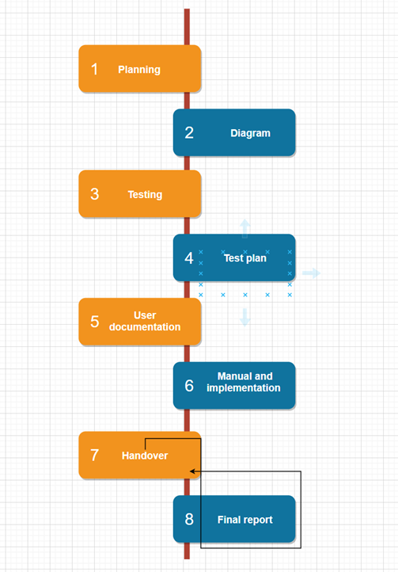

*• Existing resources will help updating or merging current resources or starting from scratch. This Will help to find anything and everything that will make sure the accuracy our work and effort.*

*• Style guides is mandatory for documentation. This project requires us to write technical documentation in a specific way which have a style guide that explains what language to use, how to talk to users, and even grammatical styles.*

4.3 Plan for crating user and technical documentation

*1. Planning: we know the purpose and scope of the project. This may seem obvious but spending time up front can reduce the actual writing time as well as head off costly, significant changes during the project. We did make sure to identify goals, existing resources (internal, contract or outsourcing), style guides, deadlines, costs, and final deliverables.*

*2. Drafting: Start with a high-level outline on all topics to be covered. Which we are doing throughout splint 1, Then, begin gathering the specific content and supporting graphics, making sure to leave placeholders for any information gaps. After drafting procedures, we are after self-review to make sure this work performs each procedure as we have written it. Above all, we are focusing that the client must be able to easily understand and navigate through the content.*

*3. Reviewing: Typically, project formal reviews take place upon completion of a first draft and a final draft. Depending on the type of content our client looking for to developing, however, we want the supervisor to check individual sections or topics. Where new product information may still be in flux, leave time for more reviews.*

*4. Revising: Now that our first draft is ready, set up a peer review to test the accuracy. Again, we try to make sure the content is presented in a way that makes sense for our client and user.*

*5. Editing: we try to turn the document over to the technical editor, its mainly our tutor who makes sure the language has a logical flow and the content is complete and consistent. Having a second set of eyes on the content can increase both the credibility and professionalism of the entire piece.*

*6. Publishing/Maintaining. After document is signed-off by our reviewers, it’s ready for publishing. At this point, the document falls into maintenance status. Documentation must be reviewed on a regular basis by the client and supervisor and brought up to date to provide the most complete and accurate information to them. To, maintenance the guideline to avoid warning from the client.*

*Our technical approach to this way documentation can help our work to reduce risk, cut costs, and improve quality.*

# High level Project Plan

*For this Project as specified in course description we will be dividing our work into two Sprints and monitoring our progress. After that we will accumulate all our work into Prototype to present with a test Mobile app to scan barcode to our client.*

*Initially we had 6 user requirements but after numbers of stand-up meeting we decided to expand those requirements and divide into two Sprints. Though the tasks are not divided equally in two Sprints we will be working according to our estimation to finish the requirements on time. Following is the Sprint Backlog we chose for our Sprint 1:*

|  |  |  |
| --- | --- | --- |
| **Requirement** | **Condition of Satisfaction** | **Tasks & Estimates** |
| US1 As a user, I want to create an account so that I can start using scanner app. | Account creation page on login page.  Clicking that link user should be directed to registration form.  After putting credentials, the form should send an email to the respective user’s email for verification purpose.  After verification, the user should be able to login with those credentials. | *T1 The login page of the app should let the user to enter their credentials like name and email – ½ day (Riaz)*  *T2 User should be notified if the credentials are incorrect – ½ day (Riaz)*  *T3 The registration form should let user to submit it through mobile app and send verification email – ½ day (Riaz)*  *T4 Create page to show successful creation of user login – ½ day Mohammad*  *T5 User information is stored in data repository – 1 day (Kamal & Jashandeep)* |
| US2 As a user, I want to login so that I can start using app to scan barcode of cloths to save time. | The user should be able to login successfully.  The user should be able see mobile app interface.  The app should scan barcode of cloths. | *T6 The interface of mobile app should be shown after successful login – 1 day (Roshan)*  *T7 The app should be able to scan barcodes – 1 day (Roshan & Mohammad)*  *T8 Information retrieved from barcode is shown in interface – 1 day (Jashandeep)*  *T9 Design activity diagram of the account creation process – 1 day (Kamal)* |

*From our tasks that we have done in our Sprint 1 we have come up with:*

* *Login page*

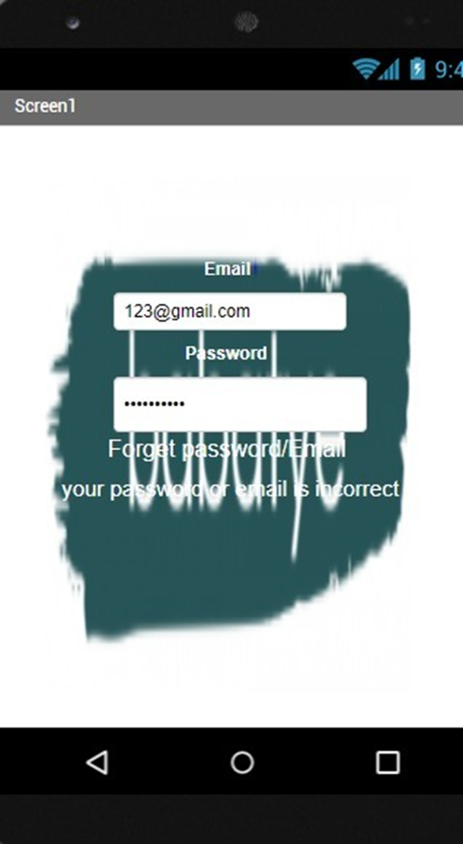

* *Database sample*

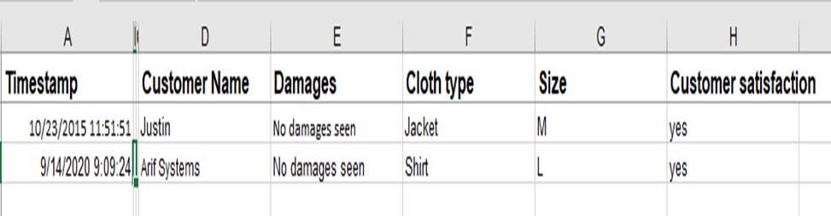

* *Scanner interface*

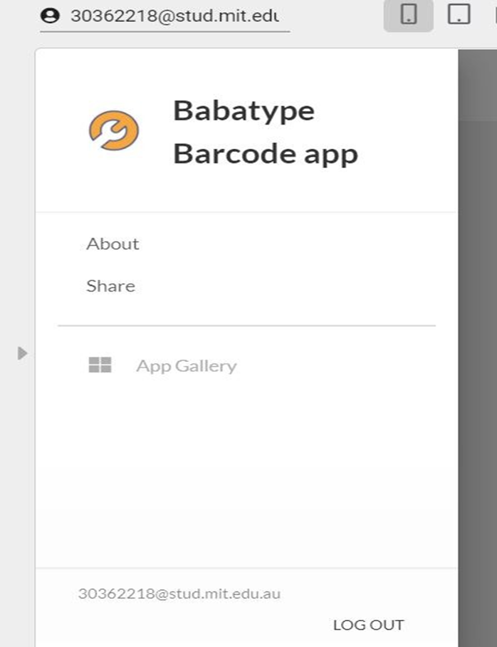

* *Information page*

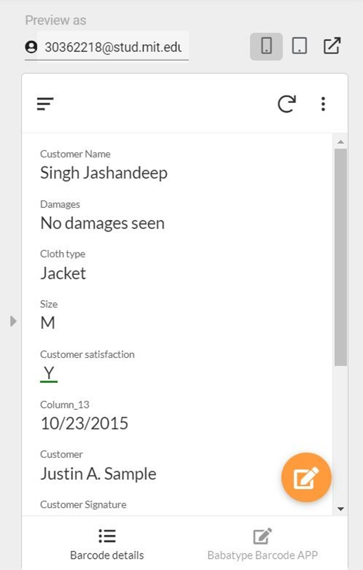

* *Activity diagram*

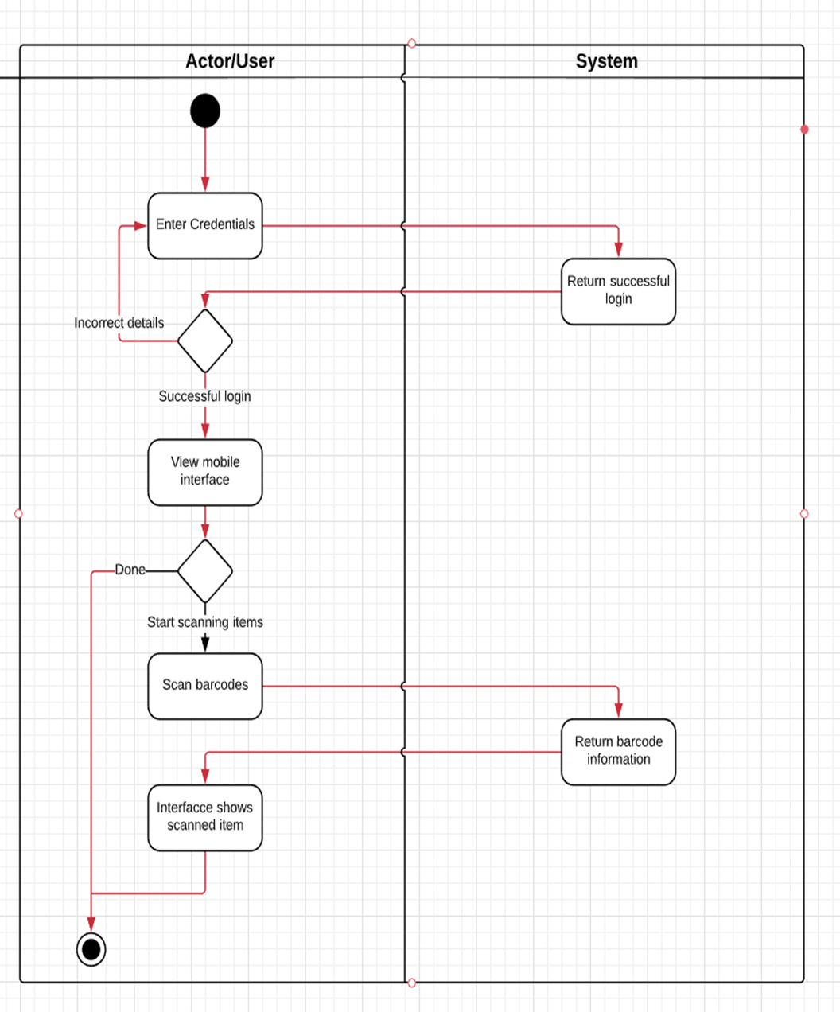

***GitHub link:*** [***https://github.com/KamalPun88/Project1.git***](https://github.com/KamalPun88/Project1.git)

***Note: We have just recently created a GitHub account and uploaded all our final work for each submission. Before that we worked through WhatsApp meeting and (Kamal) finalised it directly in MS Word.***

# Non-functional Requirements

*Non-functional requirements are basically meant as the process of judgement of entire operating system regarding various aspects to ensure that the conditions are met successfully. Explicitly stating the qualities of execution such as platform, usability, safety, security, etc., this part paves the way of system development serving certain constraints and restriction while designing. Some of the applicable non-functional requirements are briefly explained below:*

## 6.1 Platform

*The application to scan barcodes will be built with the help of Google Developer tool that will allow the developers to have access to a range of built-in functionalities. Also, it gives a user version control and a provision to view and edit the open source code while developing the application.*

## 6.2 Communication

*The designed application needs to communicate with the data repository with the help of scanned barcode of a product and giving information about the colour, size, care instructions, material, etc.*

## 6.3 Performance

*This application is desired to maintain the expected level of service allowing the users to instantly retrieve information and perform activities based on that. So, the built application will not be complex resulting in a smooth and better performance and it can perform the same way even in peak hours.*

## 6.4 Security and Privacy

*To secure the application, its main users are specified by the administrator where supplier and other members of a team have access to login to the application. The system needs to have a robust backup and recovery system of data and information stored in the repository should be in a highly secured location so that the attackers do not breach the system and have access to the confidential information.*

## 6.5 Audience

*Application is targeted for the supplier teams of a clothing store. Using an application require the ability to view the screen, to understand English language, read and write, making changes such as giving input to the quantity of product left, restock information and so on.*

## 6.6 Reliability

*While considering the reliability of an application, it will have the system able to perform without any defect while scanning the code and retrieving information.*

## 6.7 Modifiability

*For any of the unforeseen bugs or to make any changes on the application, the designed application will be developed in such a way that the developers get recommendation from the users or audience and make changes to ensure the reliability of an application.*

6.8 Economic

*Development of application with the assigned platform may require premium membership requiring some cost to gain access to a required functionality of an application. The data repository on the other side acts as the storage to all the information of products and keeping it in a secured location becomes costly.*

## 6.9 Usability

*As the application design is simple, it does not have complex functions making the users capable enough to use an application by following simple steps or making assumptions to perform certain activities. Application will be developed with proper use of colour, font size and type, simple texts which are understandable regulatory or legal requirements. Consider also licensing, certification, etc.*

## 6.10 Standards

*Designed application will be accessible to use both on android and iOS system as the application will be created targeting both of the operating system users.*

# Software and Systems Architecture

## 7.1 Architecture objectives

*As per our client request the architecture objectives will as simple as possible. The scanner app we will be working on will have simple interface design that will scan barcodes from cloths provided by suppliers to client and the information obtained from the barcode will store it into data repository for future use. So our main goal is just to build a app that works on any standard mobile irrespective of OS and scans the barcode and store information to database.*

## 7.2 High-level architecture

*The architecture for the barcode scanning app will be simple as the homepage of the app will ask user for login details as email and password. Once you enter your email and password correct than you will be allowed the access of the app. Upon getting the access, you can use the app to scan the barcodes. Sometimes, system might not be able to read the barcode or if the barcode is damaged then there will be an alternative for that; you can manually scan the barcode by clicking on the “enter barcode manually”. Once the barcode is successfully scanned the data will be stored in data repository.*

*Below is the diagram for the system architecture of app.*

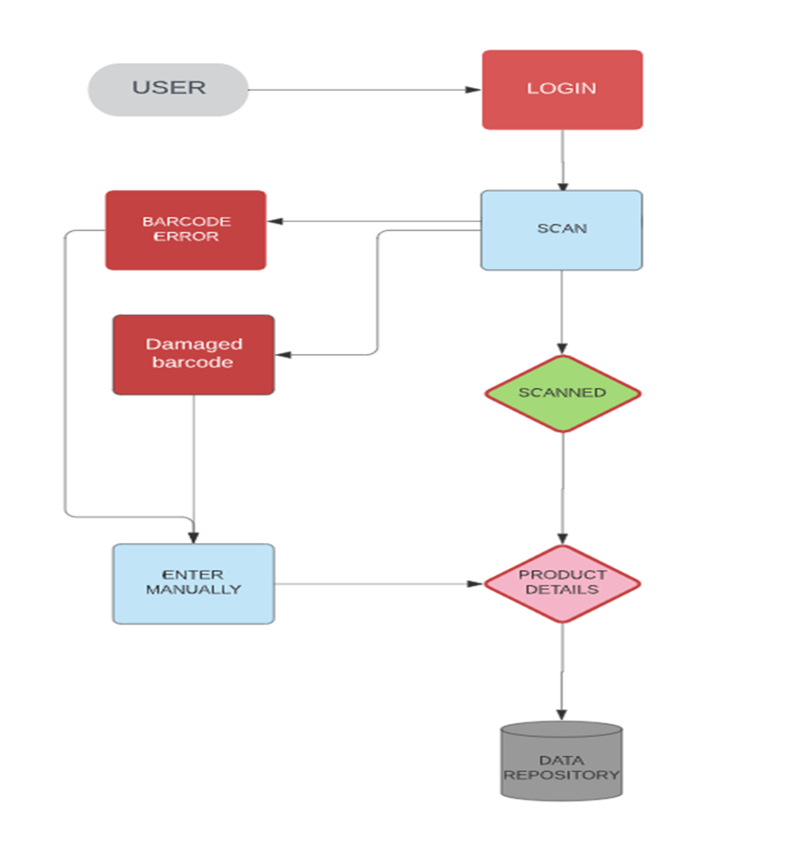

## 7.3 System context

*This will be a barcode scanning app where barcodes of the products will be scanned, and the data will be saved in data repository. The app will be capable of reading the barcodes from tags on the clothes.*

***THE HARDWARE REQUIREMENTS*** *for this app will be the mobile can be connected to internet so the app can be downloaded in the system and the second and most important requirement is that it should have a clear vision camera which can easily identify the barcode, hence the app will be working on non-camera mobile phones or tablets but the condition is that you have to enter all the details manually.*

***THE SOFTWARE REQUIREMENTS*** *will be mobile phone or tablet should be android or IOS in order to run the app. There should be enough memory in the phone to get the app downloaded.*

## 7.4 User Interface / Interaction Design

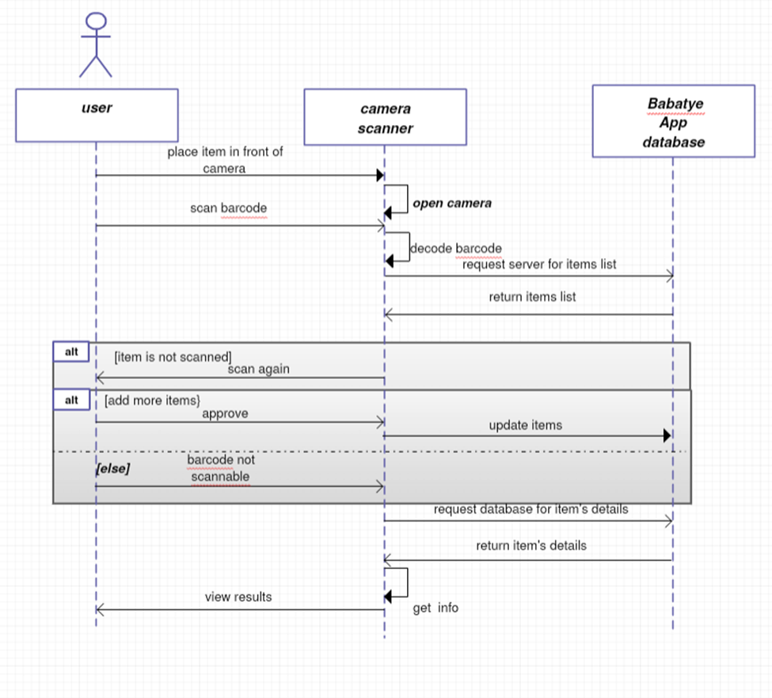

*Fig: System sequence diagram to show how user will interact to system*

***BREIF EXPLANATION***

*As a user, when I will place the item in front of the camera, camera will scan the item barcode. Then the user’s mobile app will send request to the Babatye server for the data repository and the system will return the items list. Once, the scanned items are approved, the items will be updated in the database*

*Then user’s app will request database for items details, and database will return the scanned items details. Then, the app interface will view results*

***Alternative***

*either the item is not scanned, the system will ask to rescan it or the barcode is not scannable.*

## 7.5 Data model and software design

*Development of mobile application requires series of processes and implementation of various methodologies so as to have a proper control over the developers’ task and requirements to be met. Data flow diagram assists in having a visual concept and clear understanding of what are the major processes and how can it be overcome. To analyse the core processes of mobile application development and to mitigate the possible obstacles that comes along, data flow diagram plays a crucial role.*

*The main purpose of application design and development in this project is to gather information to a Babatye clothing store in a digital form so that the supply of products becomes more convenient. Digitalization of information requires unique identity of a product which is barcode that each of the products come up with. The supplier products may have different form of barcode that an application should become able to scan. In case the barcode is misplaced or not found, product is considered as a damaged product and won’t be taken by a clothing store from the supplier. When it comes to scanning phase, some technical issues including impaired mobile camera may not work leading to not being able in collecting data of the product. The application in this case will have input details form that the users can fill up. Once, scanning process is complete or form filled up manually, data gets stored to the repository through encryption process that underlies at the backend of mobile application. The user of Babatye may require details for further use upon the request made and in similar way, decryption of code retrieves data and information of a product.*

*The overall activities that happens scanning the barcode is shown in the form of data flow diagram below:*

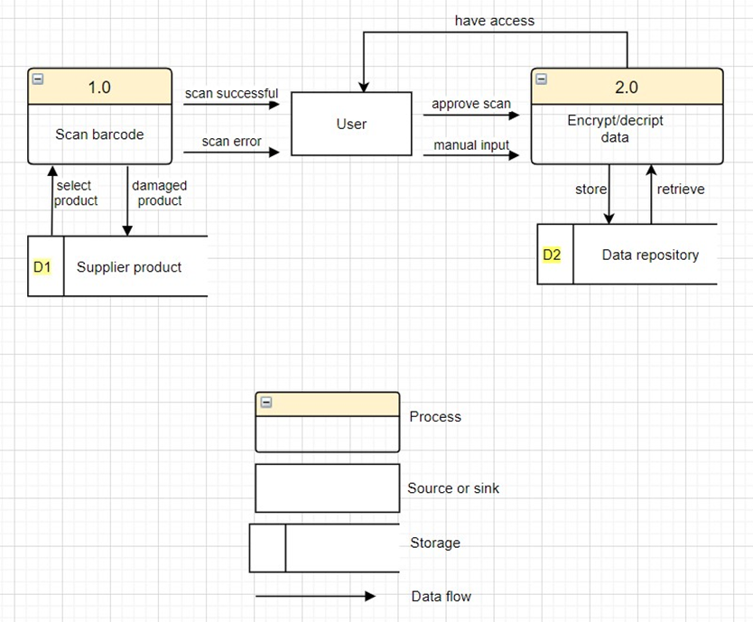

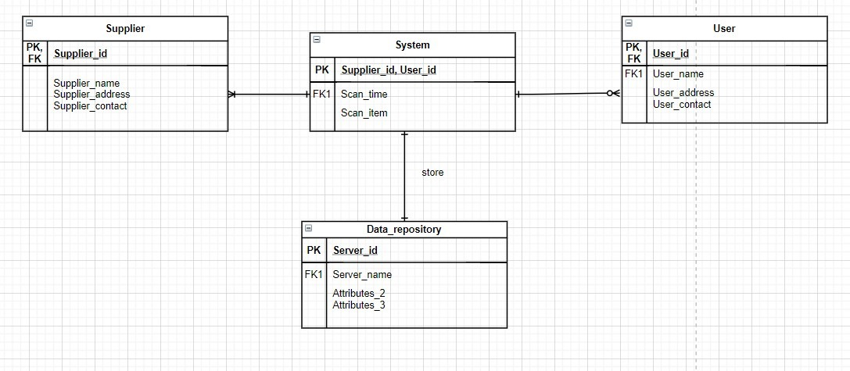

*Fig: ER diagram for System Architecture*

## 7.6 Assumptions

*This system we design for huge number of users. So, at a same time they can be able to scan their product and get the result. Some time when the system got busy it became slow and the users, they complain that. So, we try to make an alternative system which call mirror process so that in a busy condition the system can be use smoothly and everyone can get their service without lacking and all.*

*If our business is operating, shaping, and maintaining an online reputation our responsibility increase. Initial steps typically include about our services such as:*

*• Setting up Google Alerts for anything brand related.*

*• Claiming business on the major platforms like Yelp, Google My Business, and niche review sites.*

*• Setting up social media monitoring accounts (Hootsuite, Brand watch, Mention).*

*• Getting blog up and running*

*This apps mainly design for all kind of customer. So, we try to develop that accordingly so that it can run on IOS android any kind of phone with camera.*

## 7.7 External Dependencies

*An external dependency is a particular type of project dependency. It is outside of the direct influence or control of the project team, but it must nonetheless be accounted for when planning or managing a project schedule.*

*In our example, we got two kind of customer one is who use it in their mobile phone anywhere any time and another one is those who are the employee so generally their version is different. The first kind of user can use the app anytime but employee they use both internal memory system where all the data storage available or if any kind of accident happen there is another option where we hire some third party companies to store our data in cloud so that it has always backup even though some accident happen.*

*Monitoring is also important in managing the external dependencies. Having regular meetings to review the dependencies is very important.*